Failed Case Use: Invalid Credentials

Feature: SauceDemo Login

    Scenario: Invalid Credentials

        Given Launch Firefox Browser I

        When Open a SauceDemo Login Page I

        And Enter username "standard_user" and password "incorrect"

        And Click en Login Button.

        Then verify error.

        And close I

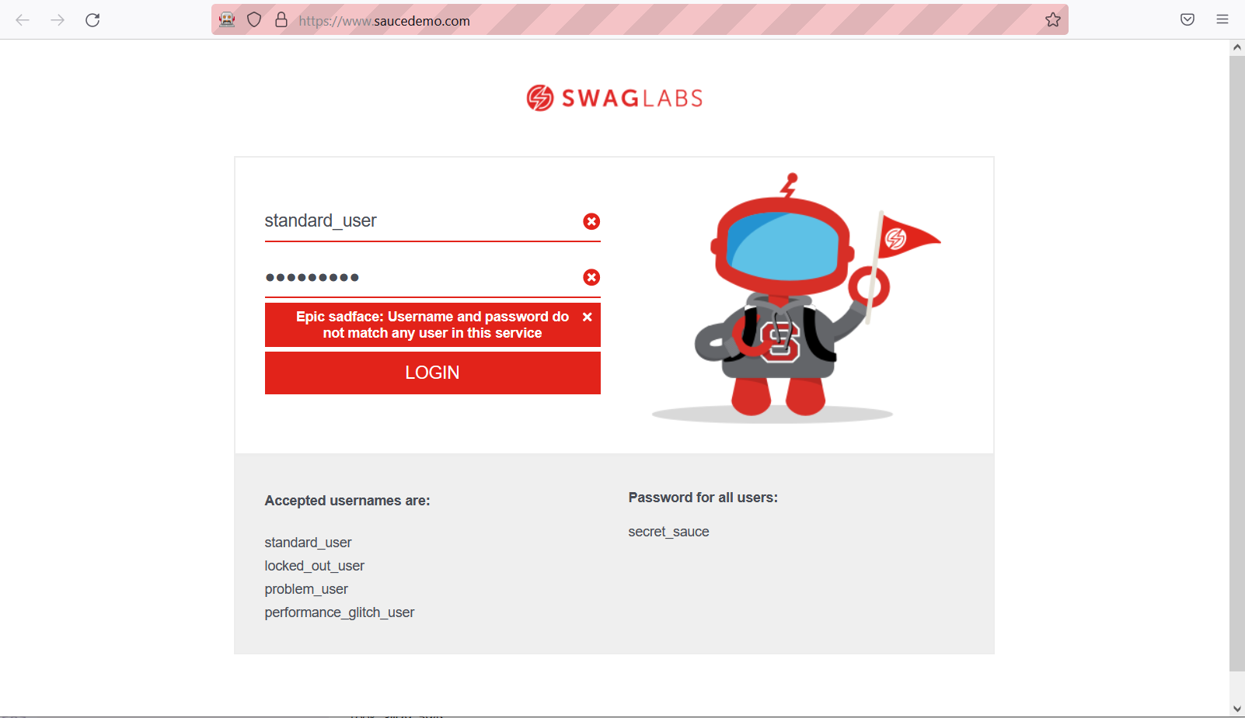

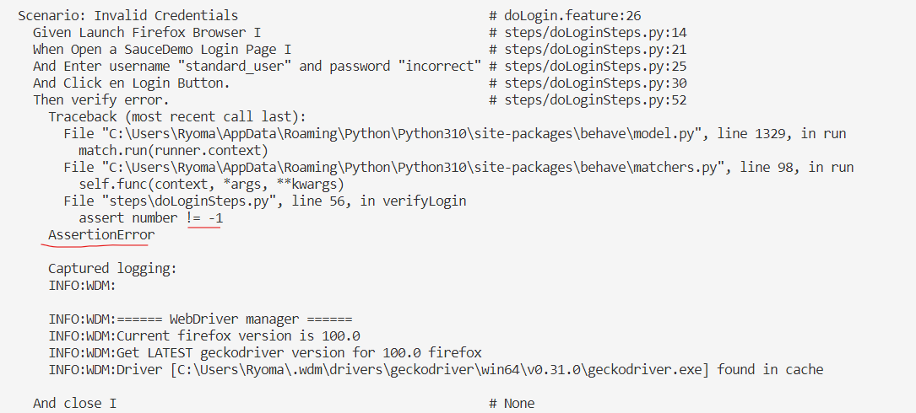

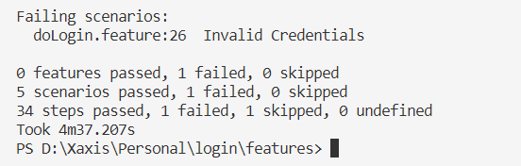

Code Implement verify function

@**then**('verify error.')

def **verifyLogin**(context):

    number = -1

    errorText = WebDriverWait(context.driver, 10).until(EC.visibility_of_any_elements_located((By.XPATH, '//h3[@data-test="error"]')))[0]

    assert number != -1